Generative AI, Cognitive Offloading, and Question Formation:
A Conceptual Model of Question-Regeneration Displacement in Human-AI Interaction

Abstract
The concern that generative AI weakens human thinking is widely noted but poorly specified. Drawing on three bodies of literature—research on epistemic agency and question-asking, cognitive offloading and critical thinking, and evaluation shift and overreliance—this paper argues that existing accounts predominantly frame the problem in terms of individual skill erosion, processing offloading, or bias during solution evaluation. What remains undertheorized is the displacement of question regeneration: whether the process of noticing a discrepancy, holding it unresolved, reformulating it, and taking ownership of it as one's own question remains user-held, or shifts toward the AI-mediated interactional system.
This paper introduces the concept of question-regeneration displacement to describe this shift, and proposes a four-layer operational model of AI-mediated thinking to identify how question formation, hypothesis construction, processing, and recalculation are differentially implicated in this displacement. The model is offered as an operational decomposition for conceptual analysis, not as an empirical taxonomy. The paper distinguishes between AI-generated questions that function as scaffolds for the user's regenerative process and those that function as substitutes for it. Scope conditions under which AI assistance is more likely to function as a substitute are identified, and conceptual diagnostic questions for future empirical investigation are proposed.
The paper contributes a theoretically grounded construct for understanding one undertheorized risk of generative AI use: the erosion not merely of users' ability to produce correct answers, but of their capacity to regenerate questions as their own.
Keywords: generative AI; cognitive offloading; epistemic agency; question formation; human-AI interaction; metacognition

Introduction
The widespread concern that generative AI weakens human thinking is often dismissed as alarmist or imprecise. Yet the concern may point to a genuine but poorly specified problem. The issue is not, as critics rightly note, that AI systems are causing a general decline in intelligence. Rather, it may be that specific cognitive functions—those through which humans form, hold, and transform their own questions—are being altered in ways that existing frameworks have not fully captured.
Understanding this concern requires moving from the crude category of "stupidity" toward a process-specific analysis. Cognitive science has long recognized that thinking is not a unitary capacity (Stanovich, 2011). Different cognitive functions—including working memory, critical thinking, metacognition, and question formation—operate at different levels and are susceptible to different kinds of disruption. This heterogeneity matters, because the effects of generative AI on human cognition are unlikely to be uniform. Whether AI reduces critical thinking engagement (Lee et al., 2025; Gerlich, 2025), redistributes cognitive effort, or alters epistemic agency (Woodruff & Hewitt, 2026) depends on which cognitive process is implicated, under what conditions, and in what kind of task.
A growing body of empirical and theoretical work has begun mapping these effects. Research on epistemic agency suggests that AI-mediated fluency may reduce the maintenance of inquiry and the resistance to premature closure (Woodruff & Hewitt, 2026; Jose et al., 2025). Studies on question-asking and answer-evaluation show that learners often fail to regulate inquiry effectively when using generative AI tools, struggling to formulate effective follow-up questions and to evaluate AI responses critically (Abdelghani et al., 2025). Work on cognitive offloading and critical thinking documents associations between generative AI use and reduced critical thinking engagement and cognitive effort (Lee et al., 2025; Gerlich, 2025; Kosmyna et al., 2025). Research on evaluation shift and overreliance further suggests that AI assistance may progressively move humans toward a solution-evaluative rather than solution-generative role (Zhou et al., 2026) and increase uncritical acceptance of AI advice (Klingbeil et al., 2024), while related work on deskilling raises concerns about the gradual erosion of professional reasoning skills over time (El Tarhouny & Farghaly, 2026).
These studies make important contributions. However, they predominantly conceptualize the problem within a unidirectional framework—the erosion of individual skills, the redistribution of processing effort, or the biases that emerge during solution evaluation. What remains insufficiently mapped is a cyclical dimension of cognition under AI mediation: whether the process of noticing a discrepancy, holding it unresolved, reformulating it, and taking ownership of it as one's own question remains user-held, or gradually shifts toward the AI-mediated interactional system.
The risk, in other words, is not merely that users come to rely on AI-generated answers. It is that the system may come to displace the very process by which humans regenerate their own questions.
More precisely, this paper introduces the concept of question-regeneration displacement to describe this shift. Question regeneration refers to the process by which a user notices a discrepancy, holds it as an unresolved problem, reformulates it, and takes ownership of it as their own question. Question-regeneration displacement occurs when this process—rather than remaining user-held—is progressively assumed by the AI-mediated interactional system: when AI-mediated fluency supplies polished framings, ready-made problem definitions, and smoothed questions before the user has undergone the friction of regenerating the question as their own.
This is not a claim that AI-generated questions are inherently harmful. AI can serve as a valuable scaffold for inquiry, prompting reflection and supporting exploration. The concern raised here is more specific: when AI-generated questions function not as scaffolds but as substitutes for the user's own regenerative process, a qualitatively different displacement occurs—one that existing accounts or measures of overreliance, epistemic agency, or cognitive offloading do not fully capture.
To develop this argument, the paper proceeds as follows. Section 2 reviews the existing literature across three domains—epistemic agency and question-asking, cognitive offloading and critical thinking, and evaluation shift and deskilling—and identifies the gap that motivates this paper. Section 3 proposes a four-layer model of AI-mediated thinking to explain where and how question-regeneration displacement occurs. Section 4 examines the conditions under which this displacement is most likely to arise, and distinguishes it from adjacent constructs. Section 5 discusses implications for AI design, educational practice, and future research.

2. Literature Review

2.1 Generative AI and the heterogeneity of cognitive effects
The question of how generative AI affects human thinking has attracted growing attention across cognitive science, educational research, and human-computer interaction. Yet the relevant literature does not converge on a single mechanism. Rather, studies have examined different cognitive functions under AI mediation—ranging from critical thinking and cognitive effort (Lee et al., 2025; Gerlich, 2025) to epistemic agency and inquiry maintenance (Woodruff & Hewitt, 2026) to question-asking skills and answer evaluation (Abdelghani et al., 2025). This heterogeneity is not noise; it reflects the genuine complexity of how AI assistance interacts with cognition at different levels of processing. This complexity resonates with longer-standing accounts of cognition as distributed across persons, tools, and representational media, rather than residing solely within the individual (Salomon, 1993).
For the purposes of this review, we organize the existing literature around three partially overlapping domains. First, we examine work on epistemic agency and question-asking under AI mediation, which addresses how AI affects the maintenance of inquiry and the formation of questions. Second, we turn to research on cognitive offloading, critical thinking, and cognitive effort redistribution, which addresses how AI changes the distribution of processing work. Third, we consider studies of evaluation shift, overreliance, and deskilling, which address behavioral and skill-level consequences of AI reliance. Across these three domains, we identify a consistent pattern: existing accounts tend to frame the problem in terms of individual capacity erosion, processing offloading, or evaluative bias—without yet mapping a more cyclical dimension of cognition that this paper addresses.

2.2 Epistemic agency and question-asking under AI mediation
A first cluster of research addresses how generative AI affects epistemic agency—the capacity of learners and users to maintain their own inquiry, evaluate knowledge claims, and resist premature closure. Woodruff and Hewitt (2026) argue that large language models risk producing what they call epistemic misalignment: the fluent, authoritative-seeming outputs of LLMs may be treated as knowledge rather than as provisional representations, undermining the reflective regulation and normative commitment that genuine knowledge-building requires. They propose designing AI systems as knowledge-building partners rather than epistemic authorities, and develop the Epistemic Agency Reflection Test (EART) as a proposed measure of users' resistance to fluent but epistemically weak AI outputs.
Related work documents the difficulty learners face in maintaining effective inquiry with generative AI. In a preprint study, Abdelghani et al. (2025) reported that middle school students using ChatGPT for a science inquiry task struggled to formulate goal-oriented questions, evaluate AI responses critically, and generate follow-up questions aligned with their learning needs. Notably, students who reported higher confidence in ChatGPT showed lower interaction quality—a divergence between perceived and actual epistemic engagement that the authors describe as an illusion of understanding. Complementary intervention research (Clerc et al., 2026) suggests that targeted AI literacy training can improve question reformulation and response evaluation, indicating that these capacities are teachable rather than fixed. Jose et al. (2025) add a structural perspective, arguing that generative AI reconfigures epistemic authority in learning environments by functioning as a surrogate knower—an entity whose fluent, assertive, and certain responses may suppress deeper questioning without users recognizing the substitution.
Taken together, this literature establishes that generative AI may affect epistemic agency, inquiry maintenance, question-asking behavior, and the perception of knowledge authority. This paper accepts these findings and builds on them. However, existing accounts in this domain predominantly frame the problem in terms of individual reflective capacity (Woodruff & Hewitt, 2026), skill-level deficits in question formulation (Abdelghani et al., 2025), or structural changes in epistemic authority (Jose et al., 2025). What they do not yet sufficiently examine is the locus of question regeneration within the interaction itself: not whether users have the capacity to ask good questions, but whether the process of noticing, holding, reformulating, and taking ownership of discrepancies as their own questions remains with the user or shifts toward the AI-mediated interactional system.

2.3 Cognitive offloading, critical thinking, and effort redistribution
A second body of work examines how generative AI affects cognitive effort, critical thinking engagement, and the distribution of processing work. Lee et al. (2025), in a study of knowledge workers reporting on 936 instances of generative AI use, found that reliance on AI was associated with self-reported reductions in critical thinking effort. Importantly, the relationship was asymmetric: higher trust in AI predicted less critical thinking engagement, while higher confidence in one's own judgment predicted more. AI use did not uniformly reduce cognitive effort; rather, it redistributed it—lowering effort in knowledge retrieval, summarization, and initial content generation while potentially increasing demands for supervision, verification, and integration. Gerlich (2025), in a mixed-method study of 666 participants, found significant negative associations between AI tool use frequency and critical thinking skills, with cognitive offloading as a proposed mediating mechanism.
Neurophysiological evidence, though preliminary, offers a suggestive perspective in the same direction. Kosmyna et al. (2025), in a preprint study of 54 participants, used electroencephalography (EEG) to compare brain activity in participants writing essays with LLM assistance, web search, or no external tool. The LLM-assisted group showed the lowest levels of neural connectivity and the lowest sense of authorship over the produced text. These findings should be interpreted with caution given the sample size and preprint status, but they offer preliminary evidence that LLM assistance may reduce cognitive engagement and ownership in ways not fully captured by behavioral measures alone.
Together, this literature documents meaningful associations between generative AI use and changes in critical thinking, cognitive offloading, and felt authorship. These are important contributions. However, like the epistemic agency literature, these studies tend to frame cognitive change in unidirectional terms: processing is offloaded, critical thinking is reduced, effort is redistributed. What remains less examined is the cyclical function of cognition under AI mediation—specifically, how the redistribution of processing effort relates to the displacement of the regenerative process by which users form their own questions. Offloading processing effort is not the same as displacing question regeneration, but the conditions under which one becomes the other remain underspecified.

2.4 Evaluation shift, overreliance, and deskilling
A third line of research focuses on behavioral and skill-level consequences of AI assistance: the shift from generative to evaluative roles, the emergence of overreliance, and the longer-term erosion of professional skills.
Zhou et al. (2026), in an observational and survey study of software developers, characterize LLM-assisted programming as shifting human activity from solution generation toward solution evaluation. Developers increasingly spent cognitive effort assessing and accepting AI-generated code rather than producing original solutions. Their analysis identified 15 categories and 90 specific cognitive biases associated with LLM-mediated development, of which 56.4% arose specifically within developer-LLM interactions. While Zhou et al. also extend their analysis to early-stage software development activities, including requirements analysis, task decomposition, and prompt formulation, these elements are treated primarily as phase-specific sources of cognitive bias within the software development life cycle. Their contribution is therefore important for showing that LLM-mediated bias can arise before final solution evaluation, but it does not model the cyclical displacement of question regeneration: the movement from detecting a discrepancy to holding, reformulating, and re-owning it as a question. While their analysis is specific to software development contexts, it suggests that LLM-mediated displacement of upstream cognitive work—including task framing and problem definition—may not be confined to programming alone, and that analogous dynamics may arise in other knowledge-intensive contexts where problem framing precedes output generation.
Klingbeil et al. (2024) provide experimental evidence for a related phenomenon: the mere knowledge that advice has been generated by AI increases adherence to that advice, even when it conflicts with available contextual information or the participant's own assessment. In incentivized behavioral experiments, participants showed higher overreliance on AI-labeled advice compared to human-labeled advice, with negative consequences extending to third parties. This effect appeared primarily through trust in the AI advisor rather than through changes in information processing—suggesting that AI's perceived epistemic authority, rather than its informational content, drives the overreliance.
Related theoretical work raises concerns about the longer-term implications of sustained AI reliance for professional skill maintenance. El Tarhouny and Farghaly (2026) argue that AI-mediated offloading in medical education may contribute to the gradual erosion of independent clinical reasoning skills—a form of deskilling in which capacities that go unused progressively atrophy.
These studies document important downstream consequences: the reorganization of human cognitive roles, the behavioral effects of AI authority, and the possible attrition of professional skill. However, they describe these consequences at the level of task execution, advice adoption, and skill maintenance. What they do not address is the question of where problem formation, discrepancy detection, and question regeneration occur in the first place—whether the shift toward evaluation, overreliance, and deskilling is itself preceded by a more fundamental displacement of the process by which users arrive at their own questions.

2.5 The insufficiently mapped region: displacement of question regeneration
Across these three domains, the existing literature provides substantial evidence that generative AI affects how humans ask questions, process information, evaluate outputs, and maintain professional skills. These contributions are real and significant, and this paper builds directly on them.
Yet a consistent gap runs through all three domains. Research on epistemic agency examines whether users can sustain inquiry and resist premature closure—but does not model where the question regeneration process itself resides within the interaction. Research on cognitive offloading examines how processing effort is redistributed—but does not trace how this redistribution relates to the displacement of the process by which users form their own questions. Research on evaluation shift and overreliance examines how humans come to accept AI-generated solutions—but treats this acceptance at the level of output, without asking where problem formation occurs upstream. Even where existing work addresses upstream activities such as task framing or prompt formulation, these are typically analyzed as phase-specific failures or bias risks. What remains insufficiently theorized is the interactional continuity through which a discrepancy, once detected, is or is not returned to the user as a question they have held, reformulated, and taken ownership of themselves.
Taken together, these three lines of evidence point to an undertheorized phenomenon: the displacement of question regeneration within AI-mediated interaction. As defined in the Introduction, question regeneration refers to the process by which a user notices a discrepancy, holds it unresolved, reformulates it, and takes ownership of it as their own question. Question-regeneration displacement occurs when the AI-mediated interactional system supplies framings, problem definitions, and smoothed questions in advance, while the user adopts the resulting question as if it had emerged from their own regenerative process.
This displacement is distinct from, though related to, the phenomena documented above. It is not equivalent to a reduction in epistemic agency, because a user can maintain reflective control (in the EART sense) while still relying on AI-generated problem framings. It is not equivalent to cognitive offloading, because it concerns the regenerative cycle of question formation rather than the redistribution of processing effort. And it is not equivalent to overreliance on AI-generated answers, because it occurs upstream—at the stage where discrepancies are first noticed, held, and transformed into questions. Section 3 introduces a four-layer model of AI-mediated thinking to explain where and how this displacement occurs.

3. A Four-Layer Model of AI-Mediated Thinking

3.1 Why an operational model is needed
Section 2 identified a gap that existing accounts do not address: whether the process of noticing, holding, reformulating, and taking ownership of discrepancies as one's own questions remains with the user, or shifts toward the AI-mediated interactional system. Existing frameworks—epistemic agency, cognitive offloading, overreliance—each illuminate part of the phenomenon, but none provides an account of where and how this cyclical process is displaced under AI-mediated fluency.
To address this gap, we propose a four-layer operational model. The model is not proposed as a psychological architecture or empirical taxonomy, but as an operational decomposition for analyzing how AI-mediated fluency intervenes in the process of question regeneration. It is intended as a conceptual tool for identifying which cognitive functions are most at stake in the displacement described in Section 2, and as a framework for future empirical and design investigation.

3.2 The four layers of AI-mediated thinking
L1: Question Formation. The layer at which a problem or question takes shape—where an unresolved issue begins to crystallize into a question worth pursuing. L1 is not where a discrepancy is first detected; it is where a discrepancy detected through L4 recalculation becomes formulated as a question after being held unresolved.
L2: Hypothesis Construction. The layer at which provisional answers, explanations, or directions of inquiry are formed in response to an established question. L2 is where interpretive scaffolding is built on the foundation that L1 provides.
L3: Processing. The layer at which information is retrieved, organized, compared, generated, or synthesized—the execution layer of thinking. L3 is the layer most readily supported by generative AI: summarization, search, drafting, and calculation all operate primarily here.
L4: Recalculation. The layer at which outputs, experiences, or accumulated evidence are compared against existing assumptions, and gaps, inconsistencies, or unresolved tensions are identified. L4 is where the user detects that something does not fit—the layer of discrepancy detection and re-evaluation.
These layers are not strictly sequential. In practice they interact, and thinking frequently cycles among them. What matters for the argument of this paper is their relative roles: L3 is the layer most frequently and most readily supported—and most frequently offloaded—to generative AI, while L1 and L4 are the layers most directly implicated in question regeneration.
Figure 1 summarizes the four-layer operational model proposed here.
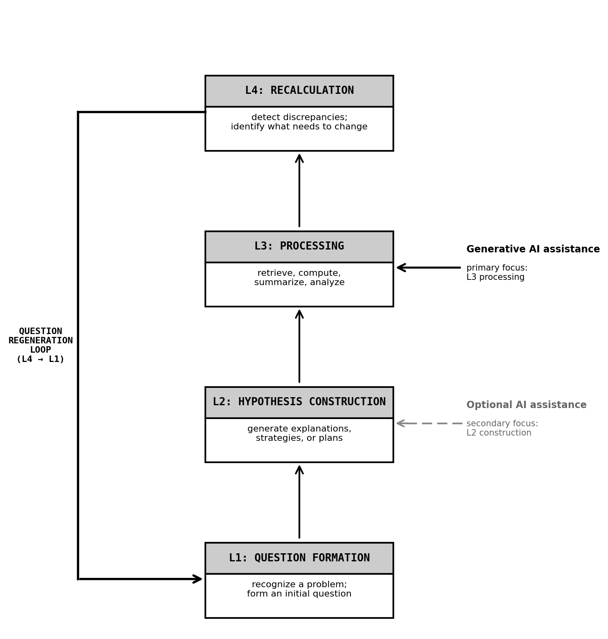
Figure 1. A four-layer operational model of AI-mediated thinking. The model distinguishes four functional layers: question formation (L1), hypothesis construction (L2), processing (L3), and recalculation (L4). Generative AI assistance primarily supports L3 (solid arrow) and optionally supports L2 (dotted arrow). The L4-to-L1 return loop—labeled question regeneration—represents the process by which a recalculated discrepancy becomes the user's own new question. Note. The model is proposed as an operational decomposition for conceptual analysis, not as a psychological architecture or empirical taxonomy.

3.3 Question regeneration as a cyclical return
Question regeneration is the process by which the result of L4 recalculation does not terminate in a revised answer or a corrected output, but returns to L1 to generate a new or reformulated question. More precisely, it proceeds through four stages:
Discrepancy detection. At L4, a mismatch or inconsistency is noticed between output, assumption, or experience and the user's existing understanding or expectations.
Holding. The discrepancy is not immediately resolved, discarded, or categorized. It is maintained as an unresolved tension—a productive ambiguity that resists premature closure.
Reformulation. The held discrepancy is transformed into a revised or new question. This is not merely a rewording; it is a reorganization of what is being asked, driven by the specificity of the discrepancy that was held.
Ownership. The reformulated question is taken up as the user's own—not as an external prompt or a borrowed framing, but as a question that carries the friction and specificity of the user's particular unresolved discrepancy.
This four-stage cycle—detection, holding, reformulation, ownership—is what we mean by question regeneration. It is not the same as asking a well-formed question, as examined in question-asking skill research (Abdelghani et al., 2025). Nor is it simply the same as resisting premature closure or maintaining inquiry, as emphasized in epistemic agency frameworks such as EART (Woodruff & Hewitt, 2026). It is the process by which an unresolved discrepancy, held and worked through by the user, becomes the user's own new question—the kind of question that could not have been generated without having undergone the friction of that holding.

3.4 Displacement under AI-mediated fluency
Generative AI systems produce fluent, coherent, and structured responses with low latency. Under typical conditions of use, this fluency tends to supply—before the user has completed the L4-to-L1 regenerative cycle—a framing, a problem definition, a follow-up question, or an interpretation of a discrepancy. The AI system does not erase the discrepancy; it pre-processes it. The result is that what would have been the user's unresolved tension becomes an AI-supplied framing that the user evaluates rather than regenerates.
We distinguish two modes in which AI-generated questions and framings can function:
Scaffolds. AI-generated framings or questions that prompt or support the user's own regenerative process—preserving the holding, reformulation, and ownership stages for the user to complete. A scaffold opens space for the user's discrepancy to develop into their own question.
Substitutes. AI-generated framings or questions that pre-supply the outcome of the regenerative process, replacing the holding and reformulation stages before the user has undergone them. A substitute closes the space by providing a ready-made question or problem definition.
Question-regeneration displacement occurs when AI-generated questions and framings function primarily as substitutes rather than scaffolds—when the AI-mediated interactional system supplies the holding and reformulation in advance, while the user adopts the resulting question as if it had emerged from their own regenerative process.
Figure 2 contrasts user-held question regeneration with the AI-displaced pattern in which AI-generated framings function as substitutes rather than scaffolds.
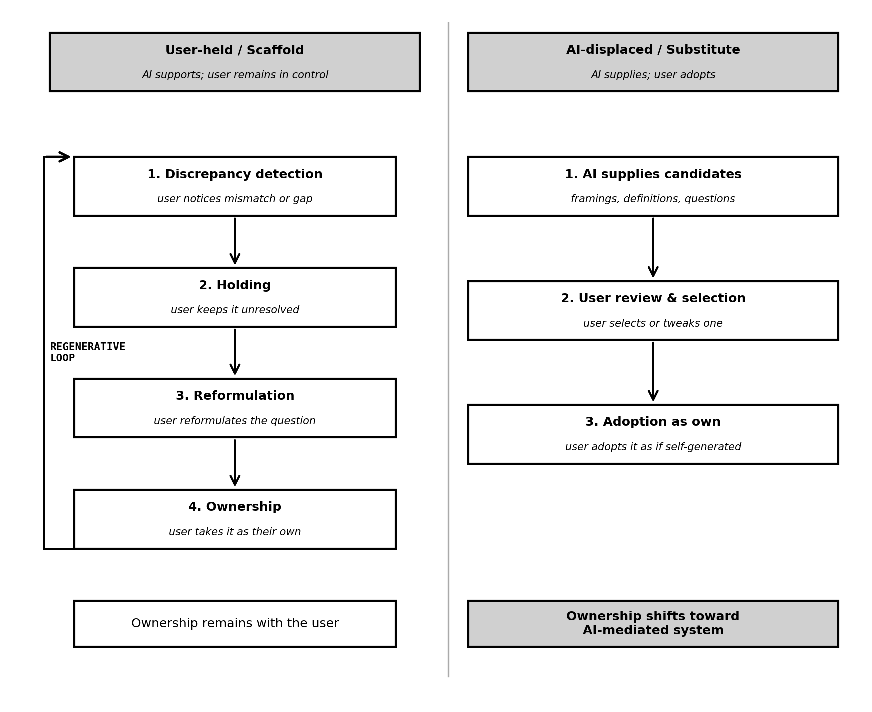
Figure 2. Two modes of question regeneration under AI mediation: scaffold and substitute. Left (user-held): the user proceeds through discrepancy detection, holding, reformulation, and ownership, with AI optionally supporting later stages. Right (AI-displaced): AI-mediated fluency supplies framings, problem definitions, and question candidates before the user has completed the regenerative process; the user adopts the resulting question as if it had emerged from their own process. Question-regeneration displacement occurs when AI-generated questions function as substitutes (right) rather than scaffolds (left).
This construct is distinct from adjacent concepts documented in Section 2. It differs from reductions in epistemic agency (Woodruff & Hewitt, 2026), because a user can maintain reflective control—resisting premature closure, demanding justification—while still accepting AI-generated problem framings as their own. It differs from cognitive offloading (Gerlich, 2025; Lee et al., 2025), because it concerns the regenerative cycle of question formation rather than the redistribution of processing effort. And it differs from overreliance on AI-generated answers (Klingbeil et al., 2024), because it operates upstream—at the stage where questions are constituted, not where answers are accepted.
The conditions under which AI-generated questions are more likely to function as substitutes rather than scaffolds—and the contexts in which this distinction is most consequential—are examined in Section 4.

4. Scope Conditions and Design Implications

4.1 Not all offloading is displacement
Generative AI support takes many forms, and not all of it constitutes question-regeneration displacement. Cognitive offloading—delegating retrieval, summarization, calculation, or drafting to an AI system—can reduce cognitive load in ways that may free attention for higher-order functions, including L4 recalculation and L1 question formation. AI assistance can serve as a scaffold for inquiry rather than a substitute for it.
This paper does not argue that AI support in general is harmful, nor that cognitive offloading is necessarily problematic. The concern raised here is more specific: the conditions under which AI-mediated fluency is likely to displace rather than support the user's own question-regeneration process.
Two contextual dimensions appear particularly relevant. The first is the nature of the task. In routine, maintenance-oriented, or low-uncertainty tasks—where the questions to be asked are known in advance and the relevant discrepancies are predictable—AI support is unlikely to displace question regeneration in any consequential way. The second is the stage of inquiry. Displacement is most consequential during exploratory or adaptive phases, where the user is still in the process of determining what the problem is—where L4 detection and L1 formulation are themselves uncertain and unresolved.

4.2 Conditions that increase displacement risk
Based on the model proposed above, several conditions appear theoretically relevant for increasing the risk that AI-generated questions and framings function as substitutes rather than scaffolds.
AI output characteristics. The more fluent, coherent, and immediately structured the AI output, the more readily it pre-packages a problem framing before the user has held the underlying discrepancy. High fluency reduces the latency between discrepancy detection and proposed framing, leaving less time for the user's holding process.
The user's epistemic state. When a user's initial sense of discrepancy is still vague or inchoate—before it has taken any shape as a question—AI-generated framings are more likely to be adopted wholesale rather than scrutinized against the user's specific unresolved tension. Conversely, users with stronger self-trust, domain familiarity, or confidence in their own judgment may be better positioned to distinguish between framings that resonate with their specific discrepancy and those that do not (cf. Lee et al., 2025).
Interactional dynamics. When AI systems provide problem definitions, question candidates, or follow-up questions before the user has had the opportunity to articulate their discrepancy in their own terms, the regenerative process is pre-empted. This differs from AI assistance that follows a user-formed question: in the latter case, AI supports L2 and L3 while leaving L1 to the user.
User interaction habits. Users who habitually accept the first well-formed question or framing provided by an AI system, without checking it against their own sense of what was unresolved, are more likely to adopt AI-generated questions as if they were their own—without having undergone the regenerative process.

4.3 Scaffolds versus substitutes in design
The distinction between scaffold and substitute is not binary but a matter of design. AI systems can be designed to preserve rather than replace the user's regenerative process.
Delaying structured output. Rather than immediately presenting a polished framing or problem definition, AI systems can first invite the user to articulate what feels unresolved—in their own, possibly imprecise terms—before offering a structured interpretation. This preserves the holding stage for the user.
Presenting multiple framings. When AI systems offer not a single problem definition but several possible framings, and ask the user to identify which resonates with their specific discrepancy, the ownership stage is returned to the user rather than pre-supplied.
Making substitution visible. When AI systems mark the source of a question or framing—making transparent that the question was generated by the system rather than emerging from the user's own discrepancy—users may be better positioned to evaluate whether it captures their actual unresolved tension.
Preserving productive friction. Scaffold design resists the impulse to smooth all ambiguity. Some degree of friction—requiring the user to work through an ill-formed discrepancy before receiving a structured question—may be necessary to preserve the holding and reformulation stages of question regeneration.

4.4 Conceptual diagnostic questions for future empirical work
The account developed in this paper is conceptual, and the construct of question-regeneration displacement calls for future empirical investigation. Existing measures of epistemic agency, question-asking skill, and cognitive offloading capture adjacent phenomena but do not directly address the locus of question regeneration within AI-mediated interaction.
Several conceptual diagnostic questions may guide future empirical research and design evaluation:
Who detected the discrepancy. Did the user identify a gap or mismatch independently, or did the AI system foreground it?
Who held it unresolved. Did the user maintain the discrepancy as an open question before seeking AI input, or did they immediately request a resolution?
Who reformulated the question. Did the user reformulate an initial sense of unease into a specific question, or did they adopt a question supplied by the AI system?
Whether the user can re-own the question. After an interaction, can the user explain in their own terms what the question was and why it mattered? Or can they only reproduce the AI-generated framing?
These questions are not proposed as a validated measurement instrument. Rather, they serve as conceptual boundaries for identifying where the locus of question regeneration resides within AI-mediated interactions—distinguishing contexts in which AI-generated framings function as scaffolds from those in which they function as substitutes. They are starting points for the design of future empirical studies, and conceptual diagnostics for the theoretical construct developed here. Implications for AI design, educational practice, and research are discussed in Section 5.

5. Implications and Limitations

5.1 Implications for AI design
The central design implication of this paper is straightforward: AI systems that intervene in intellectual work should be designed to scaffold question regeneration rather than replace it.
This means resisting the design tendency to optimize for frictionless output. Fluency is not always a virtue. When a system smooths discrepancies before the user has held them, supplies problem framings before the user has articulated their own unease, and provides structured questions before the user has worked through the reformulation stage, it displaces the very process that makes inquiry productive.
Practically, this points to the design choices examined in Section 4: delaying structured output, offering multiple framings for user selection, making AI-generated questions transparent as AI-generated, and preserving the productive friction of the holding stage. These are not calls for AI to be made deliberately unhelpful. They are calls for AI that is helpful in a way that preserves the user's role in question formation—that supports the L4-to-L1 regenerative return rather than pre-empting it.

5.2 Implications for education and practice
The concern raised in this paper has implications for how AI-assisted learning and professional practice are supported. The relevant risk is not that learners or practitioners will use AI incorrectly or produce poor outputs. It is that they will produce fluent outputs while the process of regenerating their own questions—working through unresolved tensions toward formulated problems—is progressively assumed by the AI system.
Educators and practitioners who work with generative AI can take this as a practical frame: the goal is not to teach users to verify AI-generated answers, but to teach them to re-own questions. This means creating conditions in which users are expected to articulate their discrepancies before consulting AI, to evaluate AI-generated framings against their own unresolved tensions, and to explain in their own terms why a question matters to them—rather than reproducing the framing provided by the system.

5.3 Limitations and future research
This paper is conceptual. It proposes a theoretical construct—question-regeneration displacement—and a four-layer operational model for analyzing where and how it occurs. It does not provide empirical data on the prevalence, conditions, or consequences of this displacement, nor does it validate the observable indicators proposed in Section 4.
The principal limitation follows from this: the construct is descriptively plausible but empirically underspecified. The conditions identified in Section 4.2 are based on theoretical inference rather than systematic evidence; the design principles in Section 4.3 are propositions rather than tested interventions; and the observable indicators in Section 4.4 are proxies for a construct that has not yet been operationalized.
Future empirical work may examine whether these indicators reliably distinguish scaffold from substitute use patterns, how displacement risk varies across task types and user expertise levels, and whether the conditions identified here are causally relevant. Developmental variation is also an important direction: question-regeneration displacement may manifest differently, and carry different consequences, at different stages of expertise formation.
The conceptual contribution offered here is intended as a foundation for that empirical program—and as a starting point for the design and evaluation of AI systems that preserve rather than displace the user's role in question regeneration.

6. Conclusion
This paper began with a concern that is often dismissed as too vague to be academically useful: that generative AI may weaken human thinking. We argued that the concern points to a real but underspecified problem. The risk is not a general decline in intelligence, nor simply the offloading of processing effort, nor even the adoption of AI-generated answers. The deeper risk is that generative AI may displace the process by which humans regenerate their own questions—the process of noticing a discrepancy, holding it unresolved, reformulating it, and taking ownership of it as a question.
This construct—question-regeneration displacement—is the paper's central contribution. It is distinct from adjacent phenomena in the existing literature: it differs from reductions in epistemic agency, because a user can resist premature closure while still accepting AI-generated problem framings; from cognitive offloading, because it concerns the regenerative cycle of question formation rather than the redistribution of processing effort; and from overreliance on AI-generated answers, because it operates upstream of evaluation, at the stage where questions are constituted.
To locate where this displacement occurs, the paper proposed a four-layer operational model of AI-mediated thinking: L1 (question formation), L2 (hypothesis construction), L3 (processing), and L4 (recalculation). The model is not a psychological architecture but an operational decomposition—a tool for identifying which cognitive functions are most at stake. It identifies the L4-to-L1 return—the cycle through which a recalculated discrepancy becomes the user's own new question—as the locus most directly implicated in displacement under AI-mediated fluency.
The paper is conceptual. The construct requires empirical operationalization, and the conditions, prevalence, and consequences of question-regeneration displacement remain to be established through future empirical and design research. The observable indicators proposed in Section 4 are intended as a starting point for that work, not as validated instruments.
The standard for evaluating AI-mediated thought should not be confined to whether users produce correct outputs. It should include whether users remain able to regenerate questions as their own.

References
Abdelghani R, Murayama K, Kidd C, Sauzéon H, Oudeyer P-Y (2025) The illusion of understanding: how middle-schoolers fail to regulate inquiry with ChatGPT in a science task. arXiv preprint arXiv:2505.01106v2. https://doi.org/10.48550/arXiv.2505.01106
Clerc O, Abdelghani R, Desvaux C, Poisson E, Oudeyer P-Y, Sauzéon H (2026) Teaching students to question the machine: an AI literacy intervention improves students' regulation of LLM use in a science task. arXiv preprint arXiv:2604.01955v1. https://doi.org/10.48550/arXiv.2604.01955
El Tarhouny S, Farghaly A (2026) Deskilling dilemma: brain over automation. Front Med 13:1765692. https://doi.org/10.3389/fmed.2026.1765692
Gerlich M (2025) AI tools in society: impacts on cognitive offloading and the future of critical thinking. Societies 15(1):6. https://doi.org/10.3390/soc15010006 [Correction: Societies 15(9):252. https://doi.org/10.3390/soc15090252]
Jose B, Cleetus A, Joseph B, Joseph L, Jose B, John AK (2025) Epistemic authority and generative AI in learning spaces: rethinking knowledge in the algorithmic age. Front Educ 10:1647687. https://doi.org/10.3389/feduc.2025.1647687
Klingbeil A, Grützner C, Schreck P (2024) Trust and reliance on AI: an experimental study on the extent and costs of overreliance on AI. Comput Hum Behav 160:108352. https://doi.org/10.1016/j.chb.2024.108352
Kosmyna N, Hauptmann E, Yuan YT, Situ J, Liao X-H, Beresnitzky AV, Braunstein I, Maes P (2025) Your brain on ChatGPT: accumulation of cognitive debt when using an AI assistant for essay writing task. arXiv preprint arXiv:2506.08872v2. https://doi.org/10.48550/arXiv.2506.08872
Lee H-P, Sarkar A, Tankelevitch L, Drosos I, Rintel S, Banks R, Wilson N (2025) The impact of generative AI on critical thinking: self-reported reductions in cognitive effort and confidence effects from a survey of knowledge workers. In: Proceedings of the CHI Conference on Human Factors in Computing Systems (CHI '25). ACM Press. https://doi.org/10.1145/3706598.3713778
Salomon G (ed) (1993) Distributed cognitions: psychological and educational considerations. Cambridge University Press, Cambridge
Stanovich KE (2011) Rationality and the reflective mind. Oxford University Press, Oxford. https://doi.org/10.1093/acprof:oso/9780195341140.001.0001
Woodruff E, Hewitt J (2026) Epistemic agency in the age of large language models: design principles for knowledge-building AI. AI 7(3):99. https://doi.org/10.3390/ai7030099
Zhou X, Saghi Z, Sabouri S, Pandita R, McGuire M, Chattopadhyay S (2026) Cognitive biases in LLM-assisted software development. In: Proceedings of the 48th International Conference on Software Engineering (ICSE '26). ACM Press. https://doi.org/10.1145/3744916.3773104

